Workflow to create a branch in case of adding a new capability or correcting a bug:
- Create the branch:
- Start by creating a new branch from the main branch. It's good practice to name the branch something descriptive related to the bug/new capability, you can keep the name by default when you create it from the issue (see picture below for the example Inverting FastAI0 on scope when required, I will keep all the command lines for this example issue). In this case, and for the next steps, the branch name will be 8-inverting-fastai0-on-scope-when-required.
- Creating a branch to implement a new capability or correct a bug keeps your work isolated from the main branch until it’s ready to be merged.
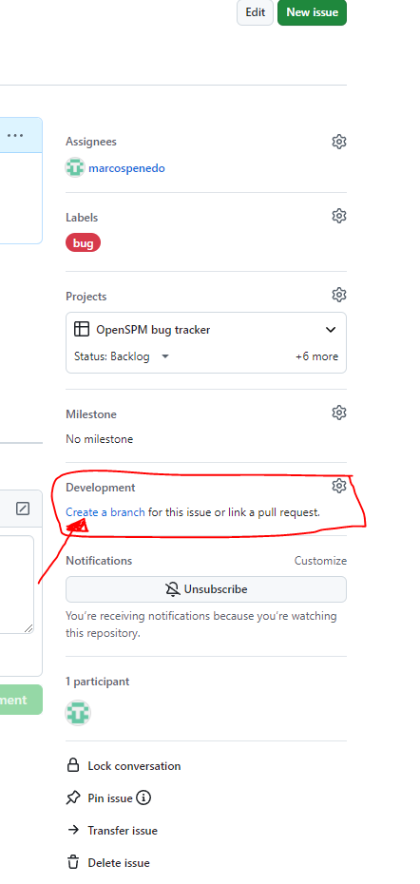

- After creating the branch, run the following commands in your local clone, going inside the local clone folder (for example, on the git bash in windows, or a terminal in mac/linux):
git fetch origin
git checkout 8-inverting-fastai0-on-scope-when-required

The first one, it retrieves the latest commits, branches, and tags from the remote repository "origin" (which is usually the default name for the main remote repository). This includes updates to all branches that exist on the remote. git fetch origin keeps your local repository's information about the remote state up to date without making any changes to your current work or branch.

Note 1: in case you did not commit the changes you made on your local clone folder, and if you’re sure you want to overwrite the untracked files, you can force the checkout with the -f option (this will permanently delete the untracked files that conflict with the files in the branch you're switching to)

git checkout -f 8-inverting-fastai0-on-scope-when-required

Note 2: it is important that every now and then, commit changes locally so in case of a problem you can come back to a previous version, do not lose all your work, by introducing the following commands:

git add .
git commit -m "Added SOS filter implementation"

Note 3: if you need to update it on the remote server, you can do it as explained below. However, it is not recommended unless you want to access it from another computer or work in parallel with someone else (it consumes the monthly bandwidth available for large files in GitHub), you can work on the local computer until the task is accomplished:

git add .
git commit –m “last changes on the branch”
git push origin 8-inverting-fastai0-on-scope-when-required

- Final merge.

Whether you should merge the main branch into your feature branch or merge your feature branch into main depends on your workflow and what you're trying to achieve.

  - Merging Main into a Feature Branch
You would merge main into your feature branch when:
- You want to update your feature branch with the latest changes from main before you finish working on the feature. For example, if someone else is working in parallel in something else and updates the main branch. If your task takes long, it is good to merge the main branch into your feature branch to incorporate the latest changes.
- This helps avoid future merge conflicts, as it keeps your feature branch in sync with the latest updates from the main branch.
- It’s usually done during active development when the main branch has changed since you started working on your feature.
git checkout origin 8-inverting-fastai0-on-scope-when-required
git merge main

In case of troubles, you can do it manually. If you want to merge the main branch into your branch and accept all files from main except for one file that you want to keep as it is on your branch, follow these steps:
Checkout your branch
- First, make sure you are on your branch where you want to merge the changes:
git checkout your-branch
- Fetch and merge main into your branch
Merge the main branch into your current branch:
git fetch origin
git merge origin/main
At this point, Git will attempt to merge main into your branch. It will show conflicts for any files that differ between the two branches, including the file you want to keep.
- Keep your version of one file
If there’s a specific file that you want to keep from your branch (and discard the version from main), use this command:
git checkout --ours <file>
For example, if the file you want to keep is myfile.txt, run:
git checkout --ours myfile.txt
This keeps the version of the file from your branch, while the rest of the files will be taken from main.
- Resolve conflicts for the rest of the files
For all other files that have conflicts, accept the version from main by running:
git checkout --theirs <file>
Alternatively, if you want to accept all other files from main without manually resolving each conflict, you can run:
git checkout --theirs .
This will accept the version of all other files from main, except for the one file you handled in the previous step.
- Stage the files
Once you’ve decided which versions of the files to keep, stage the changes:
git add <file> # For individual files, or
git add . # To stage all changes
- Commit the merge
After staging, commit the merge:
git commit
- Push the merged branch
Finally, push the changes to GitHub:
git push origin your-branch
This will merge the main branch into your branch, accepting all files from main except the one file you wanted to keep unchanged in your branch.

This is done to keep your feature branch up-to-date with the latest changes from main.

  - Merging a Feature Branch into Main
You would merge a feature branch into main when:
- Your work on the feature is complete and ready to be merged into the main branch.
- This is usually done at the end of the development process for that feature.

git checkout main
git merge origin 8-inverting-fastai0-on-scope-when-required

This is the typical workflow when you are ready to integrate your feature back into main.

Common practice:
1. During development:
- You often merge main into your feature branch to stay updated with the latest changes in the main branch.
2. When feature is ready:
- You merge your feature branch into main when the feature is complete, often after code review and testing, when you want to integrate your completed feature back into the main codebase.

